

# LAB – FILE

**Graphics and Animation Tools - Lab**

**CSGG 4101**

Name – Rishank Gupta

Roll No. – R100217062

Sap id – 500062486

Course – B. Tech CSE-OSS

Batch – 2

*Under the guidance of…*

Dr.Durgansh Sharma

Associate professor

Department of Cybernetics

School of Computer Science(SOCS)

**Experiment -9**

**Aim: To create 3D Mountain using Blender.**

**Steps:**

1. First add a plane.
2. Subdivide the plane once and repeat the step twice.
3. Add displacement modifier to the plane.
4. Add clouds texture to the displacement modifier.
5. Add a uv sphere as a controller to adjust and move the mountains terrain.
6. Set uv sphere as the controller in displacement modifier.
7. Create a vertex group and select all vertices of the plane and assign to the vertex group.
8. Add vertex weight proximity modifier and set the vertex group created above and target object as the uv sphere.
9. In the plane settings invert the lowest and highest parameter values.
10. In vertex weight proximity modifier set distance parameter as geometry.
11. Add subdivision surface modifier and set is the first modifier for the plane.
12. At last using the sphere create your mountain structure as required.
13. Color the mountain using the required colors.

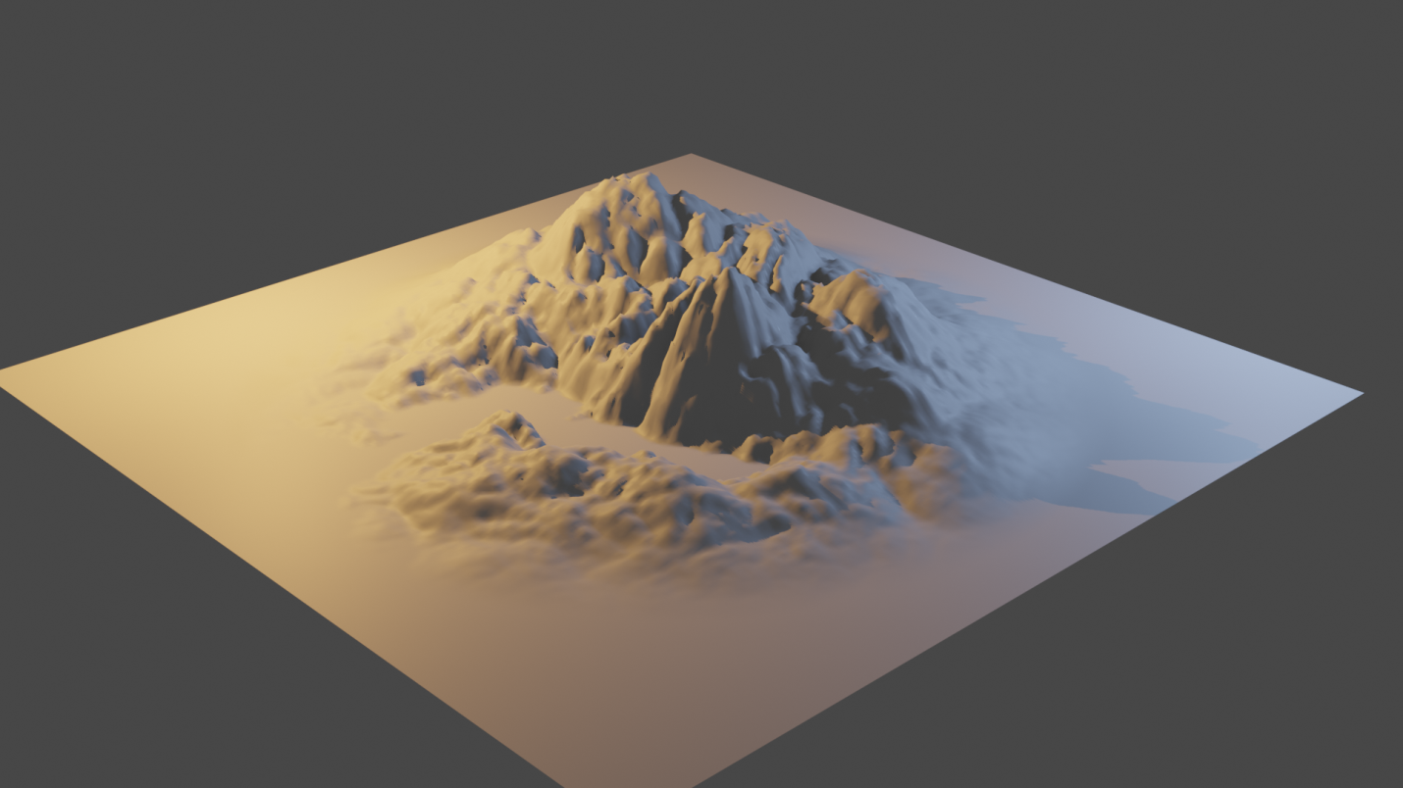

**Link:** [**https://drive.google.com/drive/folders/1oWJqICb_KQw5IOB-MqFR-NBohVmmo7Xt?usp=sharing**](https://drive.google.com/drive/folders/1oWJqICb_KQw5IOB-MqFR-NBohVmmo7Xt?usp=sharing)